NOTE: This template is shareware downloaded from www.processimpact.com. All shareware payments are donated to the Norm Kerth Benefit Fund to help a consultant who is disabled with a brain injury. Please visit http://www.processimpact.com/norm_kerth.html to make a shareware payment ($10 suggested). Thank you!
Software Requirements Specification
for
UAGC CST499 Final Project
Prepared by Chandler DeYoung
CST499: Capstone for Computer Software Technology
Professor Rangitsch
May 19th 2025
eLearning versions of several popular Process Impact training seminars are available at www.processimpact.com/elearning.shtml, including “In Search of Excellent Requirements,” “Exploring User Requirements with Use Cases,” “Writing High-Quality Requirements,” “Software Inspections and Peer Reviews,” and “Project Management Best Practices”. Single-user and corporate-wide site licenses are both available.
Table of Contents
Table of Contents ii
Revision History ii
1. Introduction 1
1.1 Purpose 1
1.2 Document Conventions 1
1.3 Intended Audience and Reading Suggestions 1
1.4 Project Scope 1
1.5 References 1
2. Overall Description 2
2.1 Product Perspective 2
2.2 Product Features 2
2.3 User Classes and Characteristics 2
2.4 Operating Environment 2
2.5 Design and Implementation Constraints 2
2.6 User Documentation 3
2.7 Assumptions and Dependencies 3
3. System Features 3
3.1 User Registration and Login 3
3.2 3.2 Course Enrollment and the Waitlist 4
4. External Interface Requirements 5
4.1 User Interfaces 5
4.2 Hardware Interfaces 5
4.3 Software Interfaces 5
4.4 Communications Interfaces 5
5. Other Nonfunctional Requirements 5
5.1 Performance Requirements 5
5.2 Safety Requirements 5
5.3 Security Requirements 5
5.4 Software Quality Attributes 6
6. Other Requirements 6
Appendix A: Glossary 6
Appendix B: Analysis Models 6
Appendix C: Issues List 7

Revision History
Name | Date | Reason For Changes | Version
Chandler DeYoung | 5/19/25 | Filling out all fields | 1

1. Introduction
1.1 Purpose
This document specifies the software requirements for the Online Course Registration System, designed for students to register, manage, and waitlist courses each semester. It ensures secure user registration, course availability tracking, and streamlined enrollment management.
1.2 Document Conventions
- Requirements will be labeled REQ.
- Priority levels are High, Medium, Low to determine how important they are.
1.3 Intended Audience and Reading Suggestions
This document is for
- Developers for system creation.
- Project managers to determine scope.
- Users to understand the system functionality
1.4 Project Scope
This system is meant to simplify the course registration process, profile creation flow, tracking enrollment, and the wait list. It will provide a secure login, course management, and tracks real time availability for classes.
1.5 References
- HIPAA Compliance Guidelines for security.
- University Enrollment Policies for managing student registration.
- User Experience Guidelines for usability.

2. Overall Description
2.1 Product Perspective
This new project will replace the manual registration and provide a secure, automated, and structured enrollment process. This will work with the existing student database and allow secure authentication.
2.2 Product Features
- Login and registration
- Course enrollment and a waitlist
- Secure authentication for logging in
- Semester based course listings
- Class availability updates
2.3 User Classes and Characteristics
- Students will register for courses and manage their enrollment.
- Administrators will control course availability and limit students per class.
- Instructors will review the students in their courses and waitlisted students.
2.4 Operating Environment
- Will be a web based site
- Operates on Windows and Mac
- SQL based data for classes and student information.
2.5 Design and Implementation Constraints
- Unique user IDs are needed in order prevent duplicates.
- Password authentication for users to login.
- Limited course enrollment per semester as determined by administrator.
2.6 User Documentation
- A user manual to help with registration and enrollment
2.7 Assumptions and Dependencies
- Students must have institution-approved credentials before registering.
- Internet access required for system functionality.

3. System Features
3.1 User Registration and Login
3.1.1 Description and Priority
Students need to register with a unique ID and password, then will be able to log in. Priority - High
3.1.2 Stimulus/Response Sequences
- The user fills out the registration form then the system validates ID & password.
- Successful registration happens then the user will get a confirmation.
- User enters login information then the system checkss credentials then grants access.
3.1.3 Functional Requirements
- REQ 1 - Each user needs a unique ID and password.
- REQ 2 - Profiles need to have the user’s name, phone number, email, and other details needed.
3.2 Course Enrollment and the Waitlist
3.2.1 Description and Priority
Students will enroll in available courses or join a waitlist if full. Priority - High
3.2.2 Stimulus/Response Sequences
- The user selects a course then the system checks availability.
- If course is full then the user joins waitlist then the system tracks order of waitlist.
- If a cancellation happens then a waitlisted user is notified.
3.2.3 Functional Requirements
- REQ 3 - Each course has a maximum number of students.
- REQ 4 - Waitlisted students need to be notified if a seat becomes available.
3.3 Course Listing
3.3.1 Description and Priority
Users can look at the available courses for each semester. Priority - Medium
3.3.2 Stimulus/Response Sequences
User chooses a semester then the system shows the courses taught in that semester.
User adds or removes courses from their schedule then the system updates status.
3.3.3 Functional Requirements
REQ 5 - Some courses may not be available in each semester.
REQ 6 - Course availability has to be constantly updated.

4. External Interface Requirements
4.1 User Interfaces
- Online site with easy navigation.
- Course listings are searchable, show waitlist statuses, and profile management.
4.2 Hardware Interfaces
Needs to be compatible with PC and mobile devices.
4.3 Software Interfaces
- Must use a SQL database for storing student and course information.
- Secure authentication for users to logins.
4.4 Communications Interfaces
- Emails for waitlist members when courses are available.
- Encrypted data transfer.

5. Other Nonfunctional Requirements
5.1 Performance Requirements
- The system should process registrations in less than 5 seconds.
- Waitlist updates should happen in real time as enrollments take place.
5.2 Safety Requirements
- Data must be safely stored and encrypted.
- The system needs to make sure nobody can access student information except the students.
5.3 Security Requirements
- Users must be authenticated through their credentials.
- Data should be encrypted for profiles and course information.
  - Software Quality Attributes
- Provide a smooth user experience.
- Should be able to scale up with more students
- Needs a simple and easy to use interface

6. Other Requirements
Needs to be in compliance with the university and governmental privacy policies. There needs to also be database backups in order to prevent lost data.
Appendix A: Glossary
- Waitlist: A list of students waiting for a specific course that is currently full. Students are ordered based on when they sign up for the waitlist
- Semester: A time period for when courses take place.
Appendix B: Analysis Models
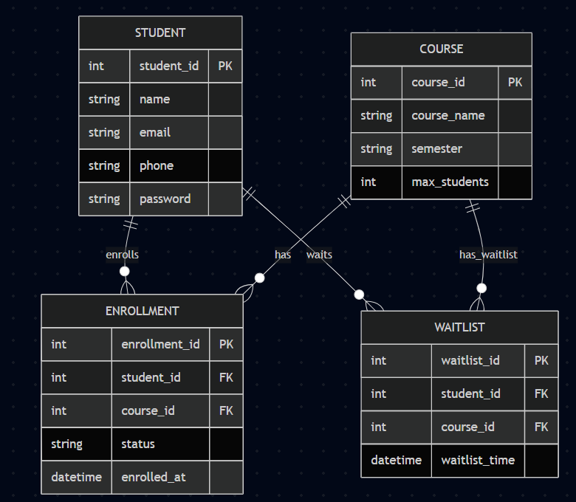Appendix C: Issues List
No issues at the moment
References:
Chamilco, M., Felix, E., Ruiz, M., Pacheco, A., Peñaranda, C. (2021, May 26). Materials and methods on digital enrollment system for educational institutions. Science Direct. https://www.sciencedirect.com/science/article/abs/pii/S2214785321031333
Key considerations for implementing a Student Enrollment Management System: GR tech. GR Tech. (n.d.). https://www.grtech.com/blog/key-considerations-for-implementing-a-student-enrollment-management-system

